September 2026

Dear Applicant

Thank you for your enquiry regarding the Shop Manager post.

Enclosed is a pack of information for this post:
- Application form
- Guidance notes
- Job Description
- Person Specification
- Monitoring form

The closing date for the return of applications is: 11:59pm on Sunday 11th October 2026.

Part of the criteria for short listing will be that applicants demonstrate the skills needed to use emails, download materials and use word processing to complete the form and therefore no hard copies of application packs will be available, and no handwritten forms will be shortlisted (unless there is an unavoidable reason then prior authorisation for submitting this way should be sought). Applications should be returned via email to: info@familiestogethersuffolk.org.uk

When completing your application form please pay particular attention to the person specification and how you meet this as criteria from this will be used at the short-listing stage. Please do not enclose a CV – to conform to our Equal Opportunities Policy applications will only be considered on our standard form. This is to ensure that all candidates are given fair treatment.

We would like to wish you good luck with your application.

Regards,

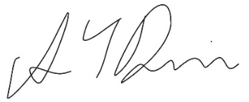

Angela Dennis
Chief Executive

